Distributed Job Processing Queue
Project Documentation & System Design
A production-grade, from-scratch job queue engine built for a placement portfolio

1. Project Overview

1.1 What Problem This System Solves
Modern applications frequently need to run work outside the request/response cycle: sending emails, resizing images, generating PDFs, processing payments, syncing data, or running scheduled reports. Doing this synchronously blocks the user and makes the system fragile — a slow downstream service (e.g. an email provider) directly slows down or crashes the API.
This project builds a distributed job queue from first principles: a system that lets producers submit units of work (“jobs”), durably stores them, and reliably distributes them to a pool of independent worker processes for execution — with guarantees around retries, failure recovery, and exactly-once-ish processing (“at-least-once with idempotency support”, explained in Section 6).

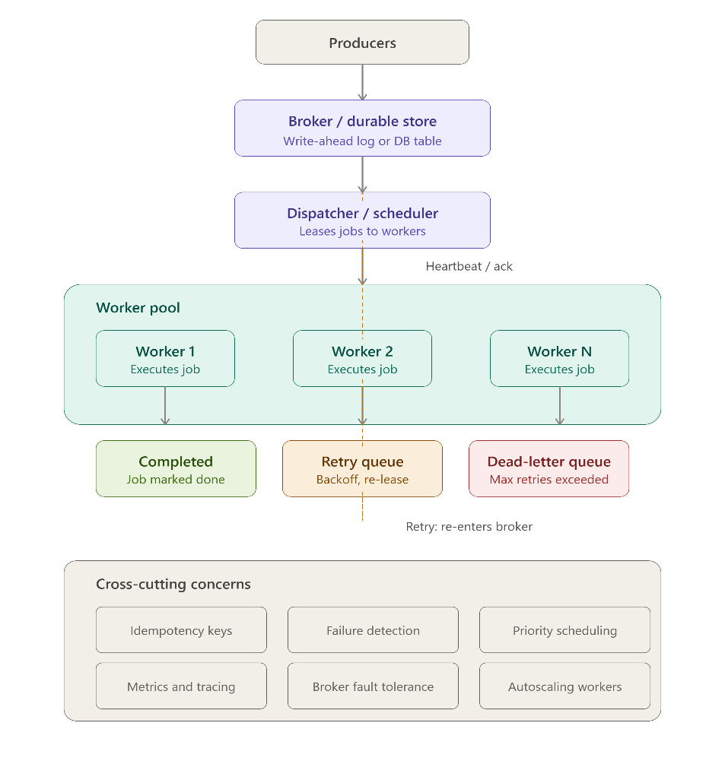

1.2 Real-World Use Cases
- Transactional email / SMS dispatch after signup, checkout, or password reset
- Image/video processing pipelines (thumbnails, transcoding)
- Report generation and data export (CSV/PDF) that takes seconds to minutes
- Webhook delivery with retry-on-failure to third-party endpoints
- Scheduled/periodic tasks (nightly billing runs, cleanup jobs)
- Fan-out workloads where one event triggers many independent tasks

1.3 Target Users
Backend teams at small-to-mid-sized companies who need reliable background processing but don't want to operate a heavyweight message broker (Kafka, RabbitMQ) for moderate throughput (hundreds–low thousands of jobs/sec). This mirrors the real-world niche filled by tools like Sidekiq, BullMQ, and Postgres-backed queues such as pgmq or Oban.

1.4 Business Value
Why this matters:
Background processing is one of the most common pieces of infrastructure in real production systems. Building it from scratch — rather than importing BullMQ — demonstrates that a candidate understands what these libraries do internally: locking, concurrency, retries, and failure isolation. That is precisely the depth interviewers probe for in system design rounds.

2. Core Features
Every feature below was selected because it maps to a real distributed-systems concept an interviewer will ask about. Features that would only pad the resume without adding engineering depth (e.g. multi-tenant billing, GraphQL layer, plugin marketplace) were deliberately excluded.
Feature | Why It's Included
Queue creation & namespacing | Models isolation between job types (e.g. "emails" vs "reports"); teaches resource partitioning.
Job submission API | Core write path; teaches request validation and durable enqueue.
Delayed / scheduled jobs | Teaches time-based querying (run_at) instead of naive cron — same mechanism as "run in 10 minutes".
Priority queues | Teaches ordering semantics with a single extra column + index; cheap to add, high interview value.
Worker registration & heartbeat | Core distributed-systems concept: liveness detection without a central heartbeat server.
Concurrent job locking (SKIP LOCKED) | The single most important concept in this project — how multiple workers avoid double-processing without a broker.
Retry with exponential backoff | Teaches failure handling and backoff strategy design.
Dead Letter Queue (DLQ) | Teaches bounding failure — poison-pill jobs must not loop forever.
Job status tracking / lifecycle | State machine design — a classic interview whiteboard exercise.
Real-time metrics dashboard | Demonstrates full-stack ability and observability thinking, not just backend code.
JWT authentication | Baseline security — expected of any "production-ready" claim.
Basic rate limiting | Shows awareness of abuse/DoS protection on public endpoints.

Deliberately excluded (and why)
Excluded | Reason
Full RBAC / multi-role permissions | Adds weeks of work for a concept (authorization matrices) not central to a queue system's story.
Caching layer (Redis) | The Postgres queries here are already indexed and fast at portfolio scale; adding a cache without a measured bottleneck is cargo-culting, not engineering.
Kubernetes / service mesh | Massive infra overhead for a single-developer, one-month project; Docker Compose demonstrates the same containerization understanding.
Multi-region / geo-replication | Distributed-systems concept worth mentioning in "Future Improvements", not worth building — no way to demo it meaningfully alone.

3. System Architecture

3.1 Overall Architecture
The system has four logical components, deployed as three separate processes so it is genuinely distributed (not just multi-threaded):
Component | Responsibility | Deployment
API Server | Accepts job submissions, exposes queue/job status endpoints, serves dashboard WebSocket stream | 1+ stateless instances behind a load balancer (or single instance for the demo)
Worker Pool | Polls for available jobs, executes handler logic, reports results | N independent processes — run several on your machine/containers to prove distribution
PostgreSQL | Single source of truth: jobs, queues, workers, job_events tables | 1 instance (Docker container)
Dashboard (React) | Subscribes to live metrics over WebSocket, renders throughput/queue depth/worker health | Static SPA served independently

3.2 Request Flow (Job Submission → Completion)
- 1. Client calls POST /queues/{queue}/jobs with a JSON payload → API server validates and inserts a row into jobs with status = pending.
- 2. A free worker polls the database (SELECT ... WHERE status='pending' ORDER BY priority, run_at FOR UPDATE SKIP LOCKED LIMIT N) and atomically claims jobs by updating status = running and locked_by = worker_id.
- 3. The worker executes the registered handler function for that job's type.
- 4. On success: worker updates status = completed and writes a job_events row.
- 5. On failure: worker increments attempts; if attempts < max_attempts, status is set back to pending with a backoff-delayed run_at; otherwise status = dead_letter.
- 6. The API server's WebSocket layer listens to Postgres LISTEN/NOTIFY (or polls aggregate stats every second) and pushes updated metrics to the dashboard.

3.3 Why Postgres as the Broker (not Redis/RabbitMQ)
Design Decision:
Postgres's SELECT ... FOR UPDATE SKIP LOCKED provides safe concurrent job claiming without a separate broker. This avoids running two pieces of infrastructure (DB + broker) and keeps the whole system operable by one person, while still being a legitimate, real-world pattern (used by GoodJob, Oban, pgmq in production).
Short answer to lead with:
"I used Postgres with SELECT ... FOR UPDATE SKIP LOCKED instead of a dedicated broker like RabbitMQ or Kafka, because it gives you safe concurrent job claiming without running a second piece of infrastructure — and it's a real production pattern, not a shortcut. Libraries like Oban in Elixir and GoodJob in Rails do exactly this."

Then explain the mechanism, so they know you understand it, not just quote it:
"When a worker wants a job, it runs a query that locks the row it's looking at. SKIP LOCKED means if another worker already has that row locked, this worker just skips past it instead of blocking and waiting. So multiple workers can poll the same table simultaneously and never grab the same job — no separate broker needed to coordinate that."

Then show you understand the tradeoff — this is the part that actually impresses:
"The tradeoff is throughput and scale. A dedicated broker like Kafka is built to handle huge message volumes across many machines with minimal latency. Postgres, since it's also handling transactional writes, will start to bottleneck under very high job volume — connection limits, lock contention, and write throughput cap out well below what Kafka or RabbitMQ could handle. So this is the right choice for small-to-medium scale systems — most companies actually operate at this scale — but if I were building for, say, millions of jobs per second across many services, I'd reach for a dedicated broker instead."

If they push further — "when would this break down?":
"Once you're running many workers hammering the same table with frequent polling, you get contention on the table and index — even with SKIP LOCKED, you're still taking locks and doing writes for every claim. At that point you'd want to either shard the jobs table, move to LISTEN/NOTIFY to reduce polling overhead, or migrate to a dedicated broker entirely."

Why this answer works well:
It shows you didn't pick Postgres because "it was easier" — you picked it because you understood the actual tradeoff (operational simplicity vs. raw scale) and made a deliberate call for the scale you're targeting. That's exactly the kind of reasoning that reads as senior-minded, not junior-naive, in an interview.

Trade-offs
Approach | Pros | Cons
Postgres-backed queue (chosen) | One less moving part; durable by default; SQL is easy to inspect/debug; strong consistency | Higher latency than an in-memory broker at very high throughput (>10k jobs/sec); polling adds slight delay vs push
Redis (BullMQ-style) | Very low latency; built-in pub/sub for push-based workers | In-memory by default (needs persistence config); another service to run and reason about; less transparent for learning purposes
RabbitMQ/Kafka | True message broker semantics, high throughput, mature ecosystem | Significant operational overhead; overkill for a portfolio project; steep learning curve for one month

3.4 Communication Between Components
- API ↔ Postgres: standard SQL over a connection pool (pg / pgx).
- Workers ↔ Postgres: same DB, separate connection pool per worker process — this is what makes them truly independent/distributed rather than threads in one process.
- API → Dashboard: WebSocket push, server broadcasts aggregate metrics on an interval + on state-change events.
- No direct Worker ↔ API communication is required — the database is the single coordination point, which simplifies the system considerably.

4. Database Design

4.1 Core Tables

queues
Column | Type | Notes
id | UUID PK
name | TEXT UNIQUE | e.g. "emails", "reports"
created_at | TIMESTAMPTZ

jobs
Column | Type | Notes
id | UUID PK
queue_id | UUID FK → queues | indexed
type | TEXT | maps to a registered handler, e.g. "send_email"
payload | JSONB | arbitrary job data
status | TEXT | pending | running | completed | failed | dead_letter
priority | SMALLINT | lower = higher priority; default 0
attempts | INT | default 0
max_attempts | INT | default 5
run_at | TIMESTAMPTZ | supports delayed jobs; indexed
locked_by | TEXT (worker_id) | nullable
locked_at | TIMESTAMPTZ | nullable — used to detect stuck jobs
last_error | TEXT | nullable
created_at / updated_at | TIMESTAMPTZ

workers
Column | Type | Notes
id | TEXT PK | e.g. hostname-pid-uuid
status | TEXT | online | offline
last_heartbeat | TIMESTAMPTZ | updated every N seconds
current_job_id | UUID nullable

job_events (audit log)
Append-only table logging every status transition (job_id, from_status, to_status, worker_id, created_at). Powers both the dashboard's live feed and post-mortem debugging — the kind of observability a real production system needs.

4.2 Indexes
Index | Purpose
jobs (status, run_at, priority) | Composite index used by the exact claiming query — the most important index in the system.
jobs (queue_id) | Fast per-queue filtering for the dashboard.
workers (last_heartbeat) | Fast scan to detect dead workers (heartbeat older than threshold).

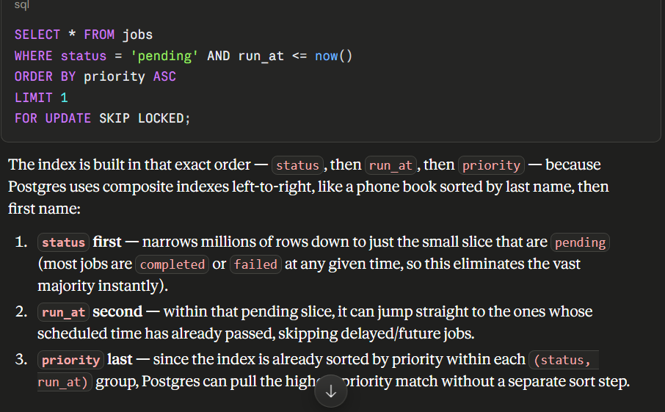

4.3 Job Lifecycle / Status Transitions
From | To | Trigger
(new) | pending | Job submitted via API
pending | running | Worker claims job via SKIP LOCKED
running | completed | Handler executes successfully
running | pending | Handler throws, attempts < max_attempts → requeued with backoff delay
running | dead_letter | Handler throws, attempts >= max_attempts
running | pending | Heartbeat sweep finds a stuck job (worker crashed mid-job)
Design Decision — Crash Recovery:
If a worker crashes while holding a job (status='running'), the job would be stuck forever without recovery. A background reaper process periodically resets jobs where locked_at is older than a timeout back to pending. This is the mechanism that makes the system fault-tolerant, and it's a strong answer to "what happens if a worker dies mid-job?" in an interview.

5. API Design
All endpoints are prefixed with /api/v1 and (except health checks) require a valid JWT in the Authorization: Bearer header.
POST /queues
Create a new named queue.
Request body:
{ "name": "emails" }
Response:
201 { "id": "uuid", "name": "emails", "created_at": "..." }
Errors:
400 invalid name (empty/duplicate) · 401 missing/invalid token
POST /queues/:queue/jobs
Submit a new job to a queue.
Request body:
{ "type": "send_email", "payload": {...}, "priority": 0, "run_at": "2026-07-02T10:00:00Z" (optional), "max_attempts": 5 (optional) }
Response:
201 { "id": "uuid", "status": "pending", ... }
Errors:
400 unknown queue / invalid payload schema · 401 unauthorized · 429 rate limited
GET /jobs/:id
Fetch a single job's current state and history.
Response:
200 { "id": "uuid", "status": "completed", "attempts": 1, "events": [...] }
Errors:
404 job not found · 401 unauthorized
GET /queues/:queue/jobs?status=&page=&limit=
List jobs in a queue with pagination and status filtering.
Response:
200 { "data": [...], "page": 1, "limit": 50, "total": 320 }
Errors:
400 invalid pagination params · 404 unknown queue
POST /jobs/:id/retry
Manually requeue a job from dead_letter back to pending (operator action).
Response:
200 { "id": "uuid", "status": "pending", "attempts": 0 }
Errors:
404 job not found · 409 job is not in dead_letter state
POST /workers/heartbeat
Called internally by worker processes every N seconds. Not for external clients.
Request body:
{ "worker_id": "w-1", "current_job_id": "uuid|null" }
Response:
200 { "acknowledged": true }
Errors:
401 invalid worker token
GET /metrics
Aggregate stats used by the dashboard on load (WebSocket handles live updates after).
Response:
200 { "throughput_per_min": 42, "pending": 12, "running": 3, "failed": 1, "workers_online": 4 }
Errors:
401 unauthorized
GET /health
Liveness/readiness probe for Docker/orchestration — no auth required.
Response:
200 { "status": "ok", "db": "connected" }
Errors:
503 if DB unreachable

5.1 Validation & Error Handling Conventions
- Request bodies validated with a schema library (e.g. Zod) at the API boundary — invalid input never reaches business logic.
- All errors return a consistent shape: { "error": { "code": "...", "message": "..." } }.
- 4xx = client error (bad input, auth, not found); 5xx = server error, always logged with a correlation ID.

6. Worker Architecture

6.1 Polling Strategy
Each worker runs a loop: poll → claim → execute → report → repeat. Polling uses short intervals (e.g. 500ms–1s) with jitter to avoid synchronized “thundering herd” polling across many workers hitting Postgres at the exact same moment.
Alternative considered — Postgres LISTEN/NOTIFY push:
Instead of polling, workers could subscribe to a NOTIFY channel and wake up instantly on new jobs. This reduces latency but adds connection-management complexity. Decision: implement polling first (simpler, provably correct), and mention LISTEN/NOTIFY as a documented future optimization — this shows awareness without spending the extra week.

6.2 Job Locking (avoiding double-processing)
The core query every worker runs to safely claim jobs from a shared table under concurrency:
UPDATE jobs SET status='running', locked_by=$1, locked_at=now() WHERE id IN ( SELECT id FROM jobs WHERE status='pending' AND run_at <= now() ORDER BY priority ASC, run_at ASC LIMIT $2 FOR UPDATE SKIP LOCKED ) RETURNING *;
SKIP LOCKED tells Postgres: if another transaction already has a row locked, skip it instead of waiting. This means N workers can run this exact query simultaneously and each will claim a distinct, non-overlapping batch of jobs — no application-level distributed lock (e.g. Redis lock) is needed.

6.3 Concurrency & Parallel Execution
- Within one worker process, jobs are processed concurrently up to a configurable concurrency limit (e.g. via a semaphore / worker pool of async tasks in Node, or goroutines + a buffered channel in Go).
- Across processes, running multiple worker instances (containers) is what makes the system distributed — the demo should run at least 3 worker containers simultaneously.

6.4 Heartbeat & Failure Recovery
- Every worker updates workers.last_heartbeat on an interval (e.g. every 5s).
- A background “reaper” job (runs in the API server or as its own small process) periodically: (a) marks workers offline if their heartbeat is stale, and (b) resets any job stuck in running with a stale locked_at back to pending — this is what recovers work when a worker crashes mid-job.

6.5 Retry Strategy (Exponential Backoff)
On failure, next run_at = now() + base_delay * 2^attempts (capped at a max delay, e.g. 10 minutes), optionally with jitter to avoid retry storms. This spreads out retries instead of hammering a failing downstream service immediately.

6.6 Dead Letter Queue
Once attempts >= max_attempts, the job moves to dead_letter instead of being retried indefinitely. This bounds the blast radius of a permanently-broken job (bad payload, deleted downstream resource) and surfaces it for manual inspection via GET /queues/:queue/jobs?status=dead_letter and manual POST /jobs/:id/retry.

7. Security

7.1 JWT Authentication
A minimal auth flow: POST /auth/login issues a short-lived JWT (access token, ~15 min) signed with a server secret. All protected routes verify the token via middleware. Full user management (signup flows, password reset, OAuth) is intentionally out of scope — a seeded admin user is enough to demonstrate the pattern.

7.2 Authorization
Kept intentionally simple: authenticated = full access. A note in Future Improvements covers per-queue API keys / scoped tokens for a more realistic multi-tenant setup, without building it now.

7.3 Input Validation
Every request body validated against a schema (Zod/Joi) before touching the database — prevents malformed payloads and is the first line of defense against injection-style bugs. All SQL uses parameterized queries; never string-concatenated SQL.

7.4 Rate Limiting
A simple token-bucket rate limiter (in-memory, per API key/IP) on the job-submission endpoint prevents a single client from flooding the queue. This is implemented at the middleware level — no external service required.

7.5 Secure API Practices
- Secrets (DB URL, JWT secret) loaded from environment variables, never hardcoded.
- HTTPS assumed at the deployment/reverse-proxy layer.
- Internal worker→API endpoints (heartbeat) protected with a separate worker token, distinct from user JWTs.

8. Performance

8.1 Database Indexing
The composite index on (status, run_at, priority) is what keeps the claiming query fast as the jobs table grows — without it, every poll would be a full table scan. This is verified during testing with EXPLAIN ANALYZE.

8.2 Efficient Queries
- Job claiming is done in a single UPDATE ... RETURNING statement (no separate SELECT + UPDATE), avoiding a race window.
- Dashboard metrics use a single aggregate query (COUNT ... GROUP BY status) rather than N queries per queue.

8.3 Pagination
All list endpoints are cursor- or offset-paginated (default limit 50, max 200) — prevents accidentally returning millions of rows and demonstrates awareness of unbounded-query bugs.

8.4 Batch Processing
Workers claim jobs in small batches (e.g. 5–10 at a time) rather than one-by-one, reducing round-trips to the database while still processing them individually.

8.5 Caching
Design Decision — No Caching Layer:
A cache (Redis) was deliberately not added. At portfolio-scale load, the indexed Postgres queries already return in single-digit milliseconds — there is no measured bottleneck a cache would fix. Adding Redis “just in case” would be optimizing without evidence, which is worse for an interview story than explaining why it isn't needed yet. This trade-off itself is documented as a talking point.

9. Deployment

9.1 Docker
Each component (API server, worker, dashboard) has its own Dockerfile with a multi-stage build (install → build → slim runtime image) to keep images small.

9.2 Docker Compose
A docker-compose.yml runs the full system locally with one command: postgres, api (1 instance), worker (scaled to 3 replicas via deploy.replicas or separate services), and dashboard. This is the single most important deployment artifact — it proves the “distributed” claim by literally running multiple worker containers against one database.

9.3 Environment Variables
Variable | Used By | Purpose
DATABASE_URL | API, Workers | Postgres connection string
JWT_SECRET | API | Token signing key
WORKER_CONCURRENCY | Workers | Max parallel jobs per worker process
POLL_INTERVAL_MS | Workers | Base polling frequency
PORT | API, Dashboard | Service bind port

9.4 Production Deployment Notes
For the portfolio demo: deploy Postgres on a managed free tier (e.g. Supabase/Railway/Neon), API + workers on Railway/Render/Fly.io, dashboard on Vercel/Netlify. This gives a real, shareable public link — far more impressive in a resume than “clone and run locally.”

9.5 Basic CI/CD
One GitHub Actions workflow on push/PR: install dependencies → lint → run unit + integration tests → build Docker images. This is enough to demonstrate CI literacy without building a full deployment pipeline, which would be disproportionate effort for a solo portfolio project.

10. Testing

10.1 Unit Testing
Pure logic in isolation: backoff-delay calculation, payload schema validation, status-transition rules. Fast, no database required.

10.2 API Testing
Integration tests against a real (test) Postgres instance via a test container or a disposable schema: submit a job → assert it's persisted with status=pending → hit GET and confirm shape — covers the actual request/response contract, not mocks.

10.3 Worker Testing
Spin up a worker against a seeded test database with pending jobs; assert it claims them, executes the handler, and transitions status correctly. Run two worker instances against the same seeded jobs concurrently and assert no job is processed twice — this directly tests the SKIP LOCKED guarantee.

10.4 Failure Testing
Simulate a handler that always throws; assert attempts increments and the job eventually reaches dead_letter after max_attempts. Simulate a worker “crash” (kill mid-job) and assert the reaper resets the job to pending after the timeout.

10.5 Retry Testing
Assert that consecutive failures produce increasing run_at delays matching the exponential backoff formula, and that a job succeeding on a later attempt correctly transitions to completed with the right attempts count recorded.

11. Future Improvements
Realistic extensions that were deliberately deferred — mentioning these shows scaling awareness without inflating the initial build:
- LISTEN/NOTIFY push-based job claiming to cut poll latency to near-zero
- Per-queue scoped API keys instead of a single global JWT (real authorization model)
- Job dependency graphs / DAGs (job B runs only after job A completes)
- Sharding the jobs table (by queue or hash) once throughput exceeds a single Postgres instance's capacity
- Distributed tracing (OpenTelemetry) across API → worker → handler
- Cron-style recurring job definitions (beyond one-off delayed jobs)
- Horizontal autoscaling of workers based on queue depth

Summary of Key Design Trade-offs
Decision | Chosen | Trade-off Accepted
Broker | Postgres (SKIP LOCKED) | Simpler ops, one fewer service; slightly higher latency than Redis at extreme scale
Job discovery | Polling with jitter | Simpler & provably correct; small latency vs push-based LISTEN/NOTIFY
Authorization | Single JWT, no RBAC | Faster to build; less realistic multi-tenant story (documented as future work)
Caching | None | No added complexity; acceptable since no measured bottleneck exists at this scale
Orchestration | Docker Compose | Easy to run/demo solo; not a K8s story, but appropriately scoped for one developer

